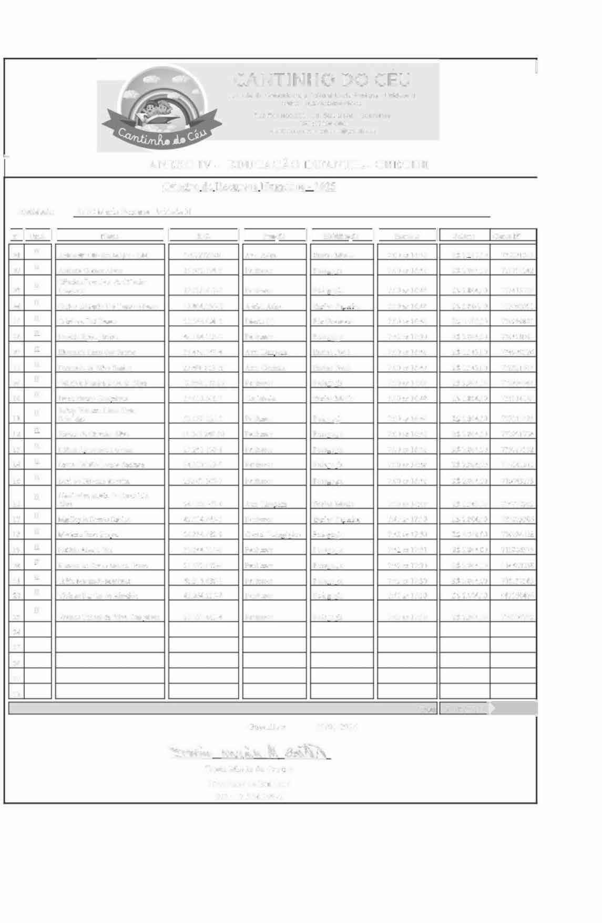
;
1
CANTINHO DO CEU
As,oel�ç•o Comun,t�rla e Cu•t�r�I Maria Santana. Unldao"• 11 CN?J: 01.,27J,298/0004•19
Rua Rona1d'o.2Cn - Jd. s1a Mena - Guarulhos
El'nOit O:C-Cln0n0EP 0$0070190tl6•o208"'0gmc>ll.eo<n
•••
f--
ANEXO IV - EDUCAÇÃO INFANTIL- CRECHE
Onadrn de Recursos JIJ1manos - 202s
ACC Maria Santana Unidade D
Entidade:

1 n• I Uald 11
li
li
11 Ha1iill1as:ao En�inoMMio
PedaS!'Ol!Í3
PedagOj!)il Emino Su .....;or
Pós Gfaduado Pedago!!ia
:Emino Fund.
:Emino Fund. Pw.-omil Emino Medlo
Pedaf:';0!!,Í� Pedae:ol!ia PedaS!'0l!Í3
Ped.lii:ol!Í� PedaS!'0,Í3
l:mirloMédio
Emino Su...-rior Pedaf:';0ll,Ía Pedae:ol!ia
Pedae:ol!ia PedaQ'0l!Í3 Peda"º"'ª
Peda11oma
Sttlárit>

RS 2 ?00,00
RS 2.804.00

RS 2.801.00
RS 3.846.00
RS 4.600.00
RS 2.804.00 RS l.$43.00
RS l.543.00 RS 2.804.00
RS 1.89'1.00

RS 2.804.00
RS 2.804.00
RS 2.804.00
RS 2.804.00
RS 2.804.00

RS 1.543.00
RS 2.80<!.00 RS 4.0liS.00 RS 2.804.00
RS 2.804,00
Conta N'

735091065
721754242

731,113729
7110()2091
734989BSl
734428941
734990526
7328:!l614
732800044
734314189

737012183
733951734
735087$52
735141911
71!11143273

73472!202
732823906
734294028
718986375
114453858
11
1
NorM
R.G.

16922727-80
19.962.194-9

18529.472-S
50.804.196--X
22564.098-3
46.184.318-3
35.448.747-4
29.498.883-X
52.898.162-26
18.0I0.30J.S

52.559.226-3
14.065.249-30
27.241,1911-6
54,110.279-5
25 867.31111-7

24,950, S65-4
42.Sl4.S'i0•3
24.S34.682-9
33.844.711-8
21.SP.072-6
48.216.638-1
42.264.236-8

27,333,441-4
Funs:ao
Horário

7:00M 16:48
7:00M 16:48

7:00 as 1 ó:'IS
7:00 as 1 ó:'IS
7:00 ll,Ç 16:48
7:42M 17:30
7:00M 16:48
7:00M 16:49
7:00 as 16:48
7:00 as 1ó:'IS

7:00as 16:48
7:00as 16:48
7:00M 1(;:48
7:00as ló:48 7:00M 16:48
7:00as ló:48 N2as 17:30
7:-12 as 17:30
7:4? as 17:31
7:42as 17:30
7:42M 17:30
N2as 17:30

7:42 as 17:30
Aotontlli Oliveir.l Maior· UI Adrunl Gomt'S Ah-es
Awt.Aclm. Pmfmor
P'wfessor
MSl5l. Adm.
Direlllr(a) Prof=or
Aux. [,.imn.-» Awt. Gotinltl Professor Cozmhetra
Professor Pro�or Pmfmor
Professor Pmfmor
�.Lim=,,
P'wfessor Coord. hda.-ó.i,,:i.co Prof=or
Prof=or Pmfmor P'wfessor
Professor
II II
II II II
II
II II
II
01
02
Cliz.eide Frandçco de Oliveira
Lourenço
C�los Edua!do Dd 13u$so Alblmo Crütiane Dei Bu.sso
Daoi�la Ruyz &truc l;lisandra I..im.t dos Sán11:>s
Femand.3 da Sih•a SantM
G;,bri: lil Pereira R.os;, <lil Sii,,a
Ivwe BuenQ QQocruves Jadely Van=a Lima Pmto
Sobrillho
Jéssica de Oliv6ra Sil\-a lü1hia Aoatecid.3 Ferr6ra
Ll•u G�hio LelllOs S:umma
uni M Oliveit:l RMSim
03
04
os
06
07
08
09
10

11
11
u
14
1S
II
II
II II II
II
Lindmalva Mana da Conceaçào
II
Silva
:Marílcvde So.ire, Sabino Marlene Braz Rooue Natália Alrudc Vaz
RoS3:tl.ll de Souza .M�cz Biano Tl1ira )vfMhldo M;t!lill� Vivime Pereira de Alwe:tda
\<í,'Íane Tchani da Silv.i Goncalves
16
17
18
l!I
20
21
íí
?l 24
25
26
27
28
II II
ll II II
II
RS 2.804.00
716137565
RS 2.SO<l.00 99215047'1
II
RS 2.804.00
734330792
RS6J.2P7,00 -
Iotal
Guamlhos
23/01/2026
"
�
� �
��v..
Tallia Maria de Casfl·D Presidente da Entidad.e RG.: 17.564.398·2

